Dŵr Uisce

Penrhyn Castle

Drain Water Heat Recovery Demonstration

in Commercial Kitchens

11th Oct 2022
Penrhyn Castle, Bangor North Wales & Online

Time | Event
10.00 – 10.30 | Registration, Coffee/Tea & Networking (location The Stables)
10.30 – 10.40 | Welcome & National Trust Motivation  Paul Southall & Enfys Evans, National Trust
10.40 - 10.50 | Dwr Uisce Project Overview & Welcome  Prysor William, Bangor University
10.50 – 11.10 | Drain Water Heat Recovery at Penrhyn Castle – Design & Performance  Aonghus McNabola, Trinity College Dublin
11.10 – 11.30 | Environmental Impacts & Benefits of Drain Water Heat Recovery  Isabel Schestak, Bangor University
11.30 – 11.40 | Open Discussion & Emerging Opportunities  Paul Coughlan, Trinity College Dublin
11.40 – 12.40 | DWHR Site Demonstration & Historical Tour of Penrhyn Castle  Tea rooms, Coal yard & general castle tour
11.40 – 12.10 | DWHR Site Virtual Tour & Online Q&A  3D online virtual tour of Team Rooms & Coal yard
12.40 – 13.40 | Lunch & Networking  Penrhyn Tearooms
13.40pm | Departure

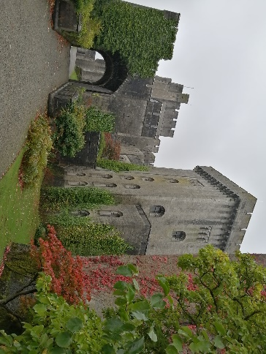 | 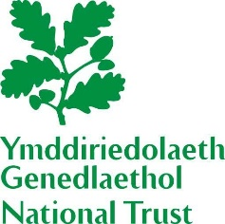 | 